**Part 2**

**Command Line**

1. 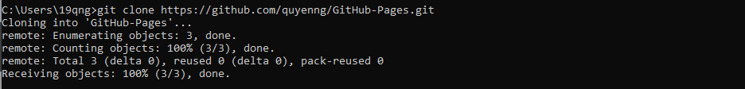
2. 
3. **Graphical user interface, text, application

   Description automatically generated**
4. 
5. 
6. 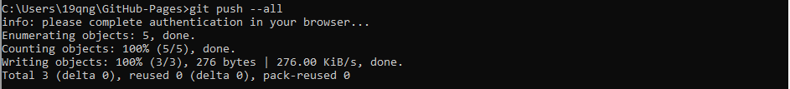

**VS Code**

